**3.HQL_NativeQueries**

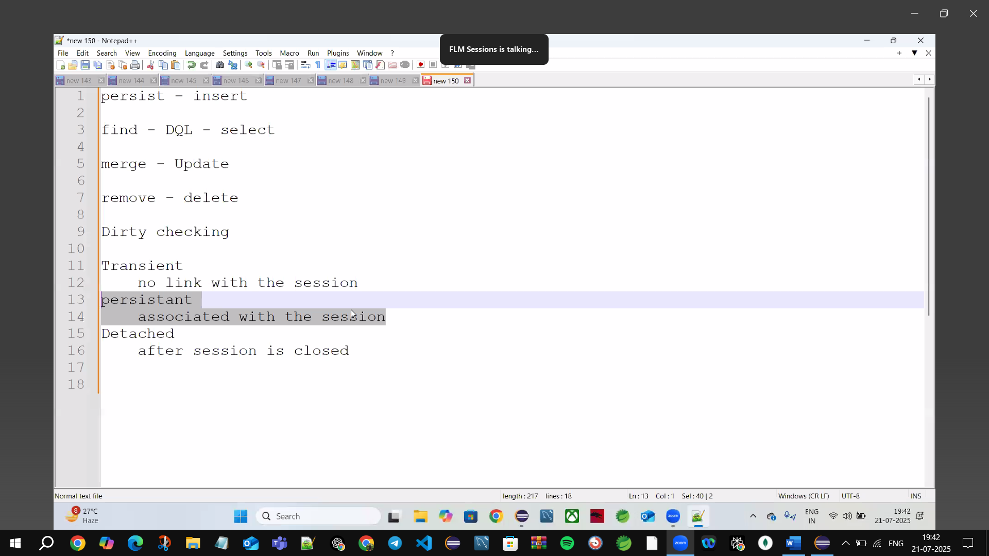

🡪Only Persistent state can Auto merge bcz of Dirty Checking

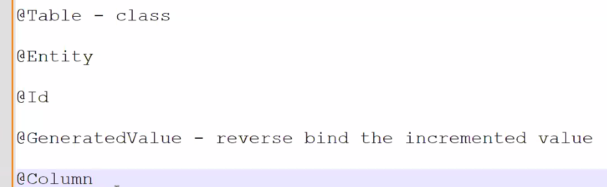

@Id Primary Key is Mandatory

@GeneratedValue🡪can’t increase the value it only binds the Increase value to the Java

🡪Auto increment done by SQL only

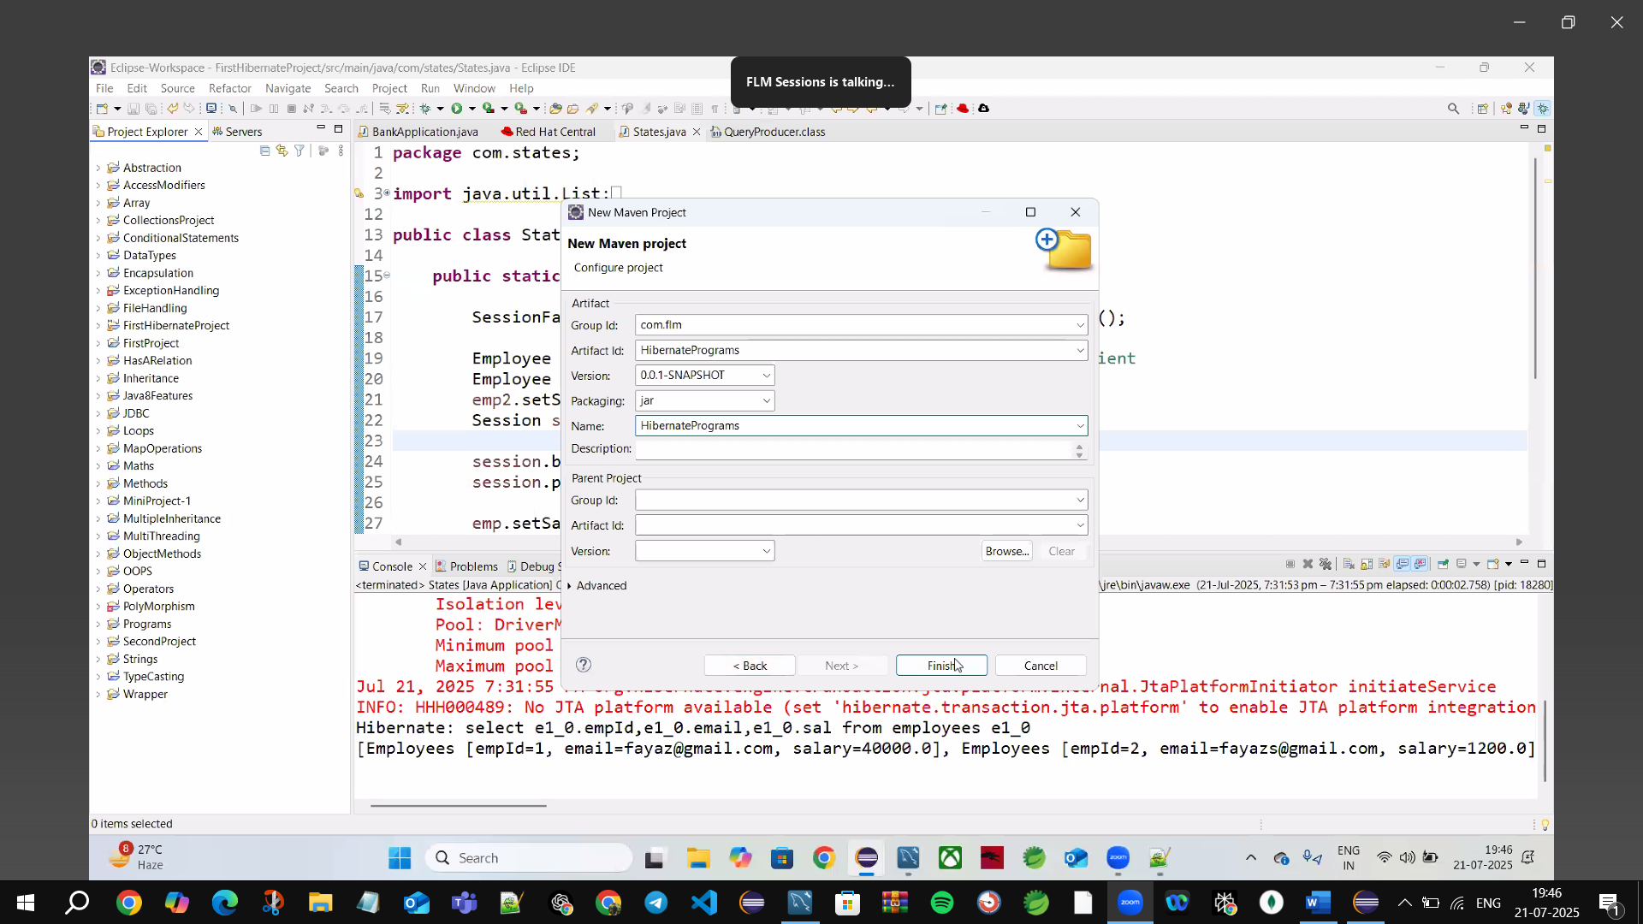

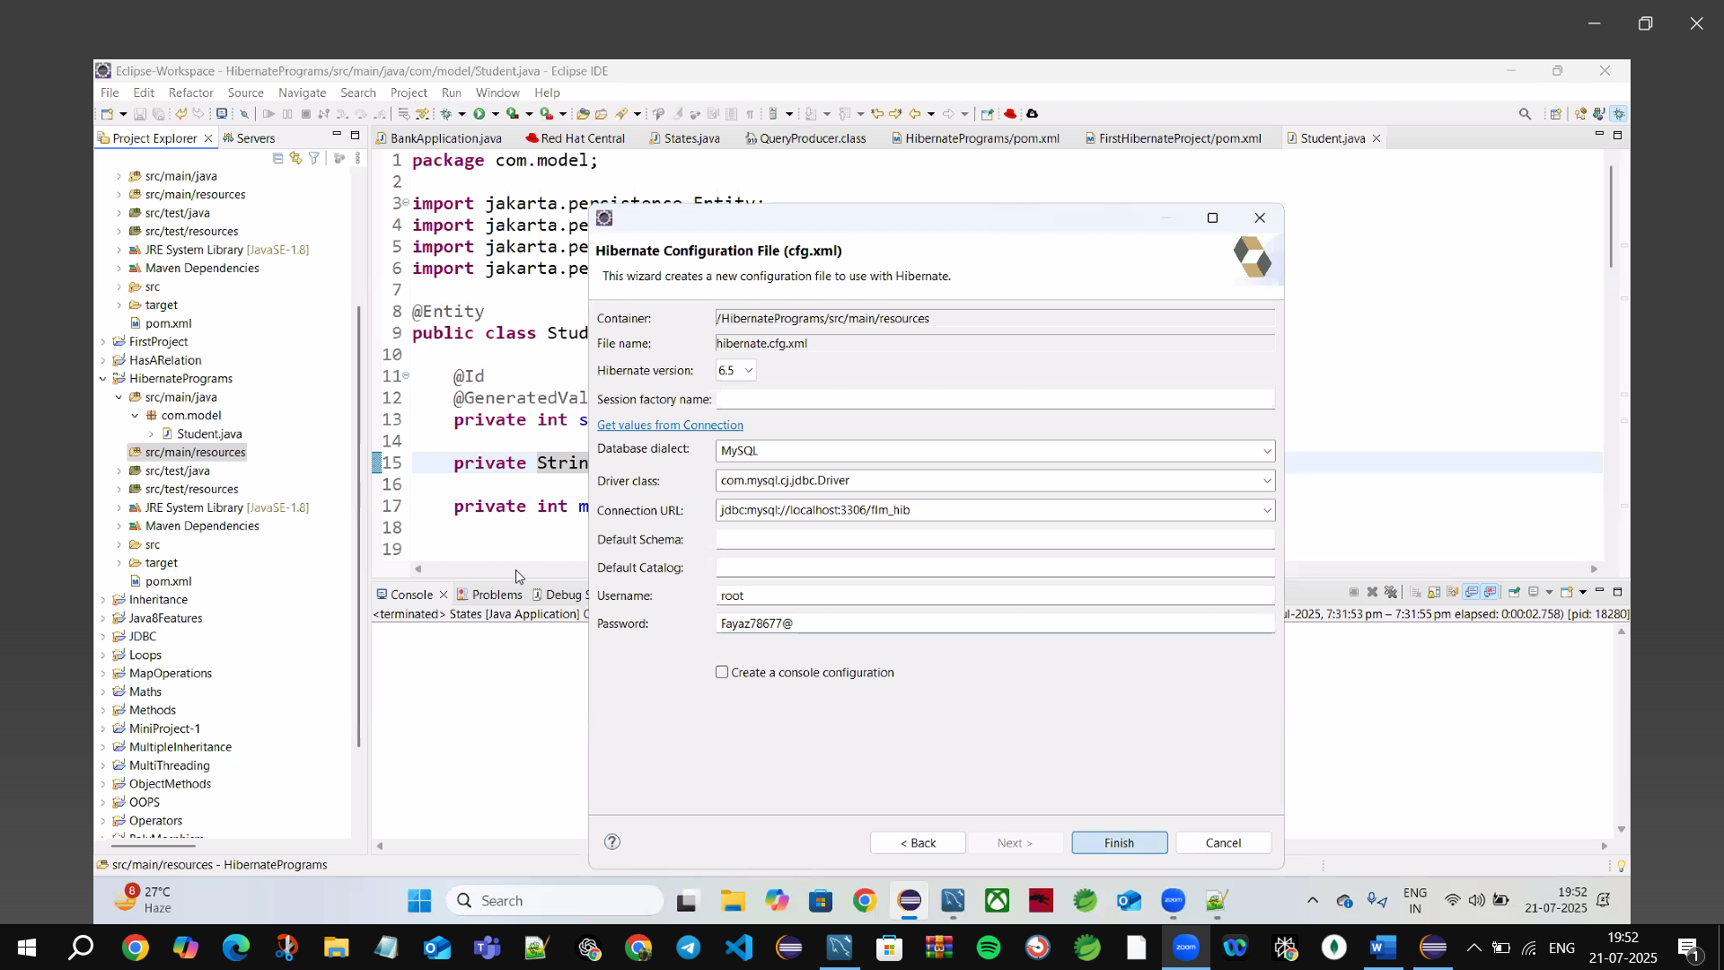

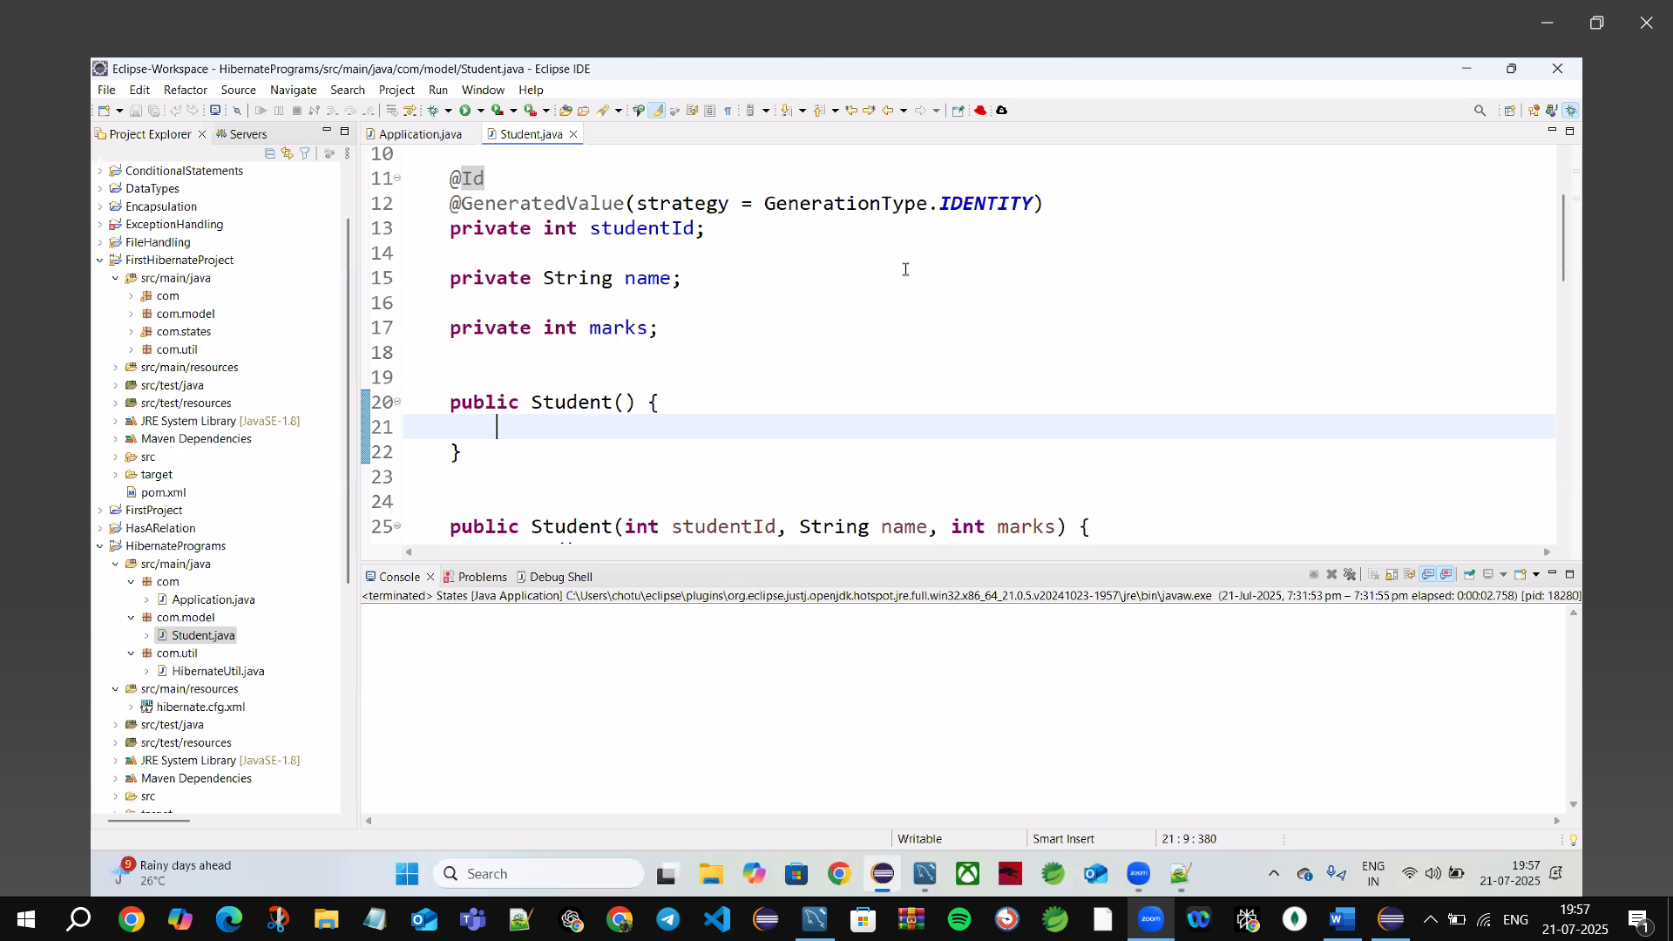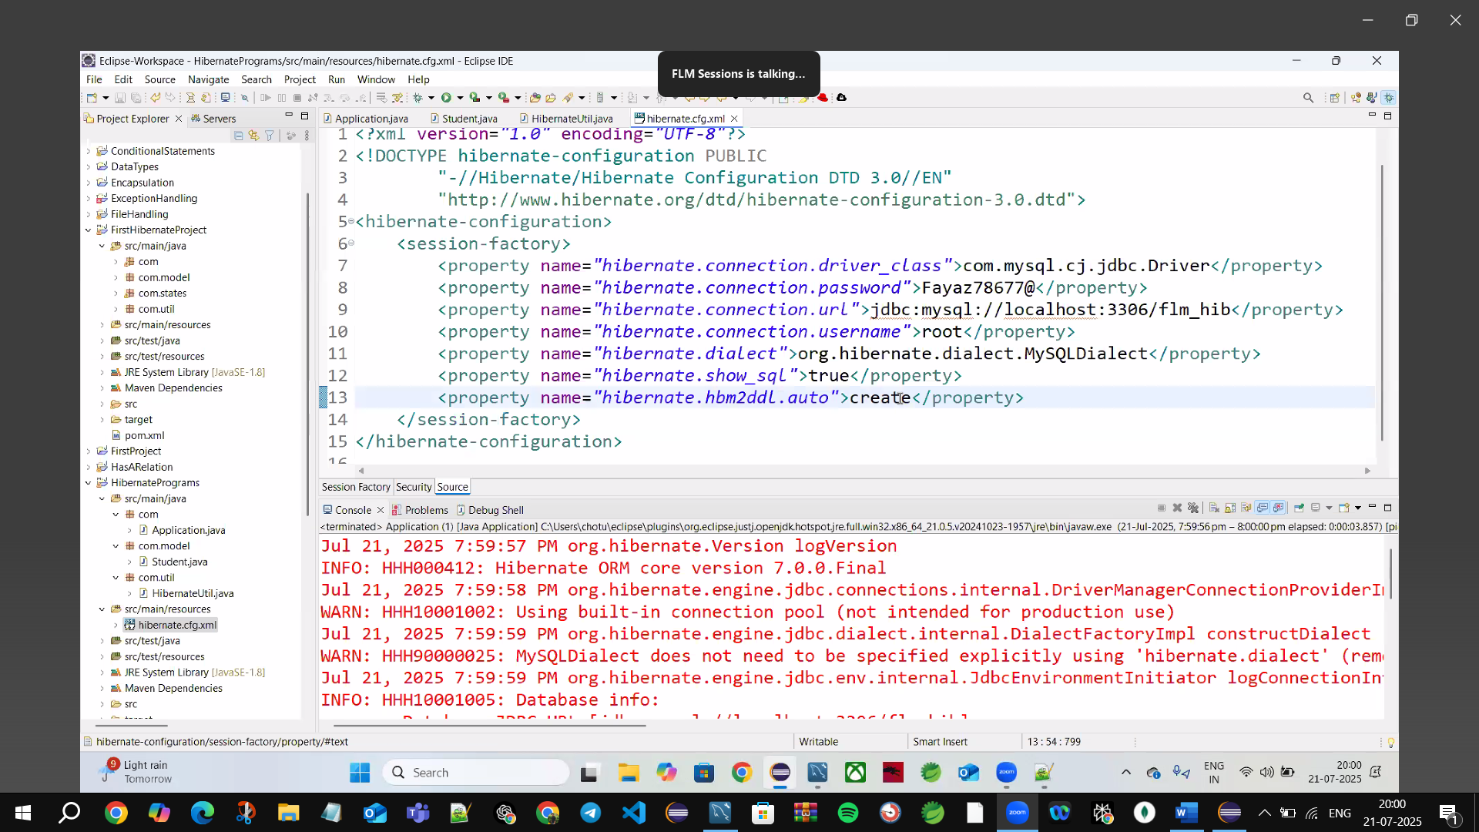

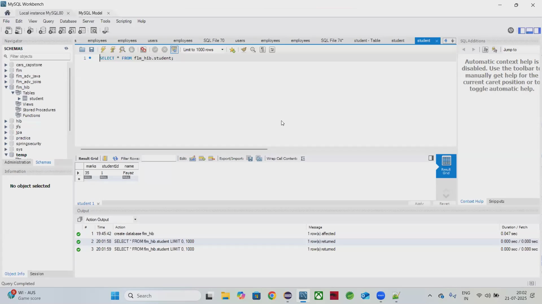

🡪Hibernate Automatically Create the tables in Data Base(MySQL) 

Hbm🡪Hibernate Mapping

🡪”hibernate.hbm2ddl.auto”>create

🡪automatically create table in D.B & internally it drops the previous data & insert new Data

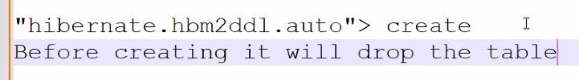

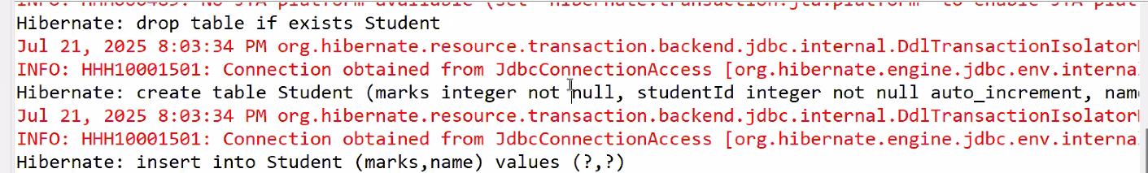

**Create🡪**every time drop the previous table & create new Table

🡪in Real time We don’t use DDL’s

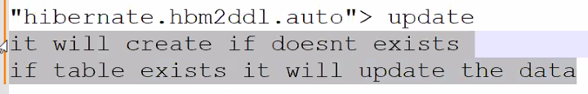

🡪Update it will not drop the existing table & it updates the data into existing table

🡪use for testing & updating in real-time

🡪DDL not handle from programs

🡪only used for Practice purpose



**None🡪**not do anything



**Create-drop🡪** same as create(1st drops existing table & create new Table)

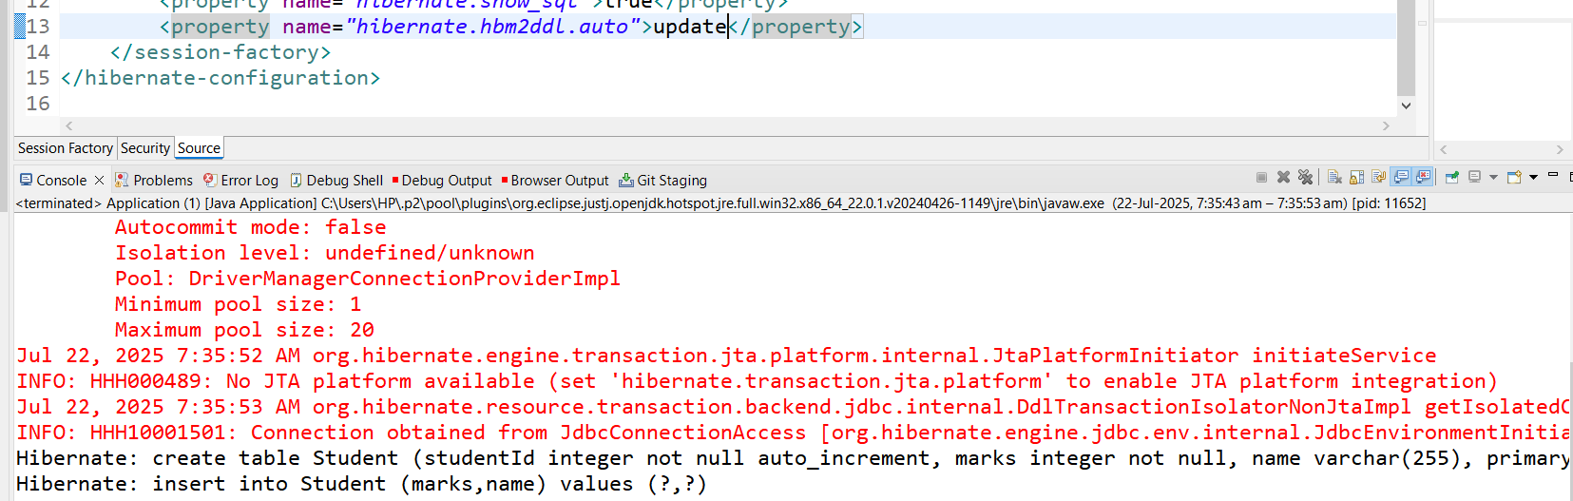



**Update 🡪**Automatically create the table if you drop an existing table and insert the data into D.B

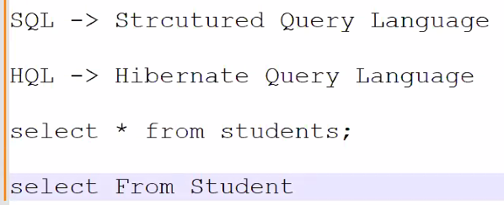

HQL🡪knows only Java Code

To Extract a Method🡪ctrl+1+Enter (change name )

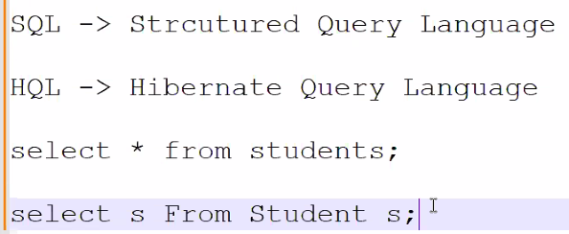



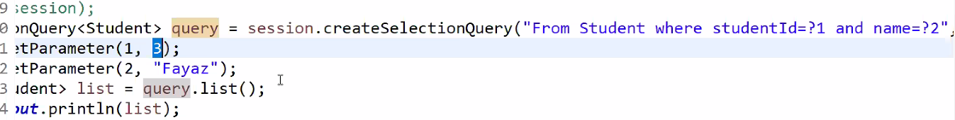

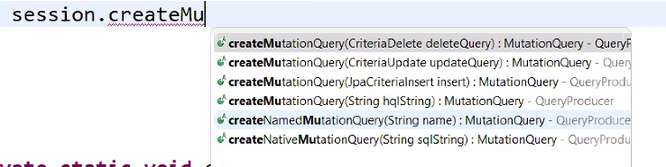

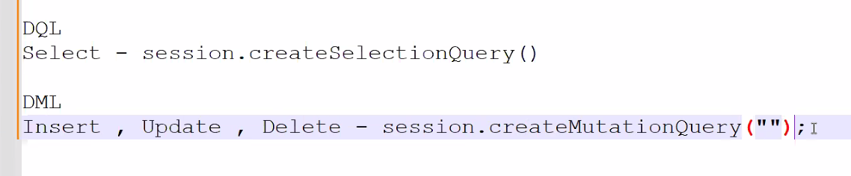

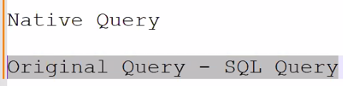

Can write JDBC in HQL🡪using Native Query

🡪Native Query same as SQL just only Change the method

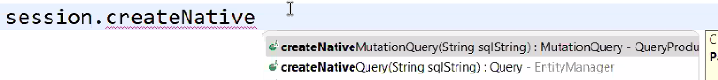

createNativeMutationQuery🡪DML

createNativeQuery🡪DQL

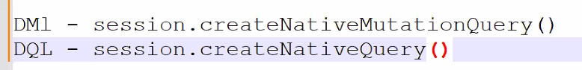



DQL🡪normal SQL don’t know HQL

**createNativeQuery🡪DQL**

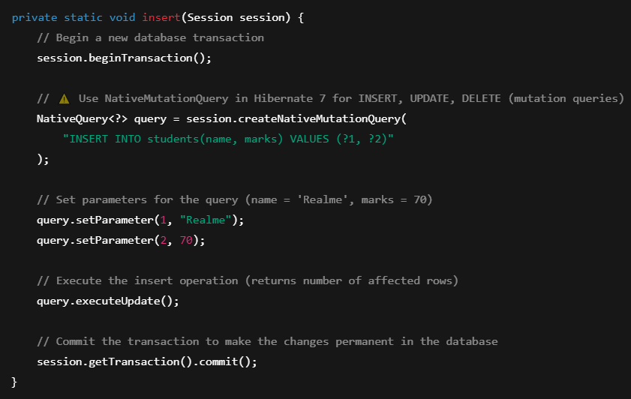

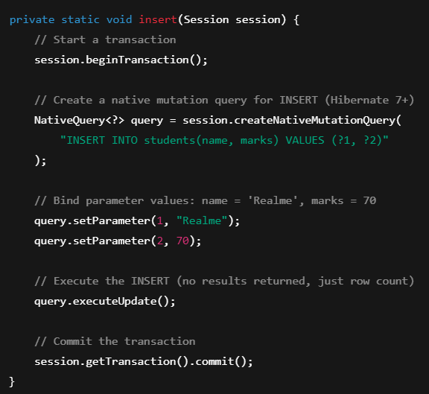

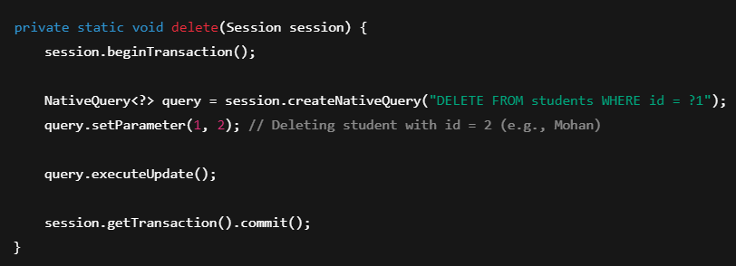

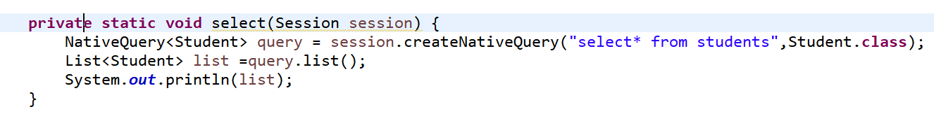

**Select**

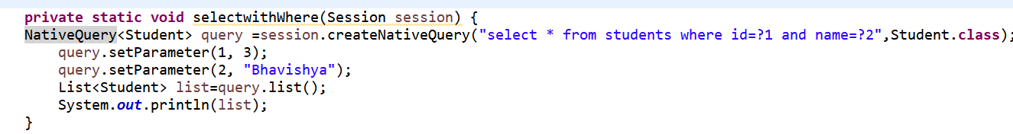

**SelectwithWhere**



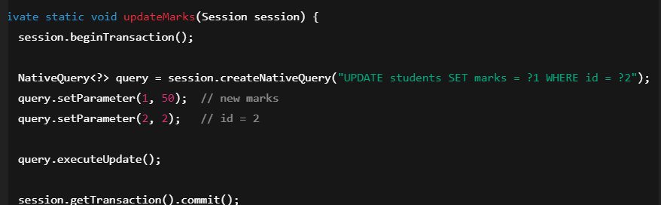

**createNativeMutationQuery🡪DML**



  

  